**AWS Workflow**

1. Navigate to www.google.com/search?q=aws&oq=&aqs=chr...
2. Click "Cloud Computing Services - Amazon Web Services (AWS)"2

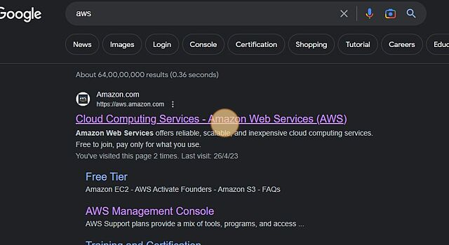

1. Click "Sign In"



1. Click the "username@example.com" field.3

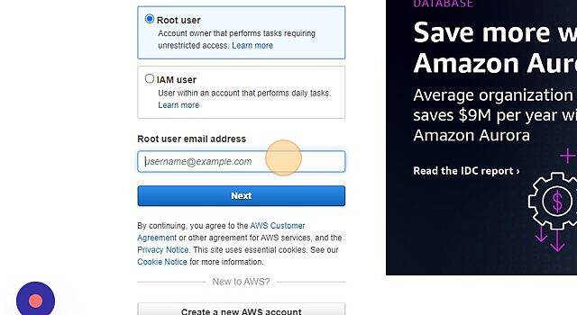

1. Click "Next"

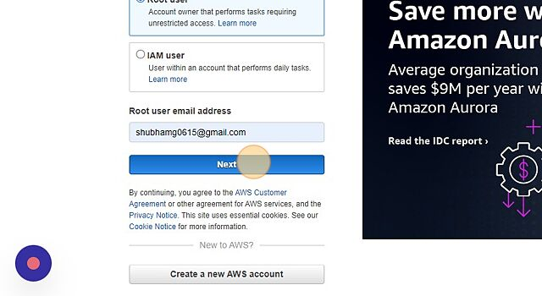

1. Click "Sign in"4

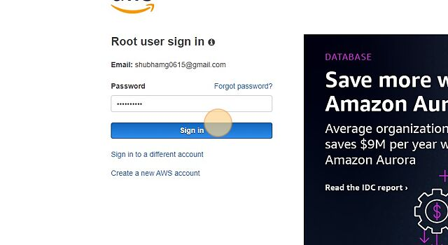

1. Click "EC2"

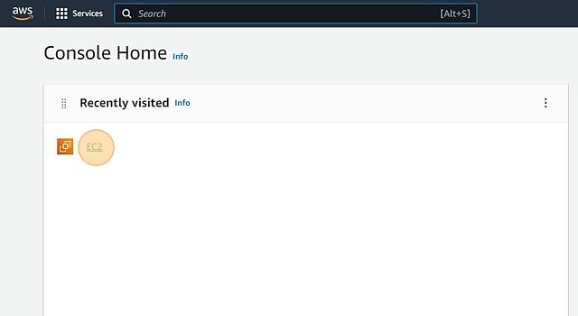

1. Click here

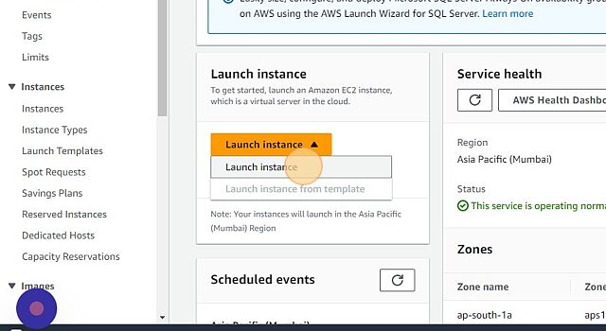

1. Give a Name 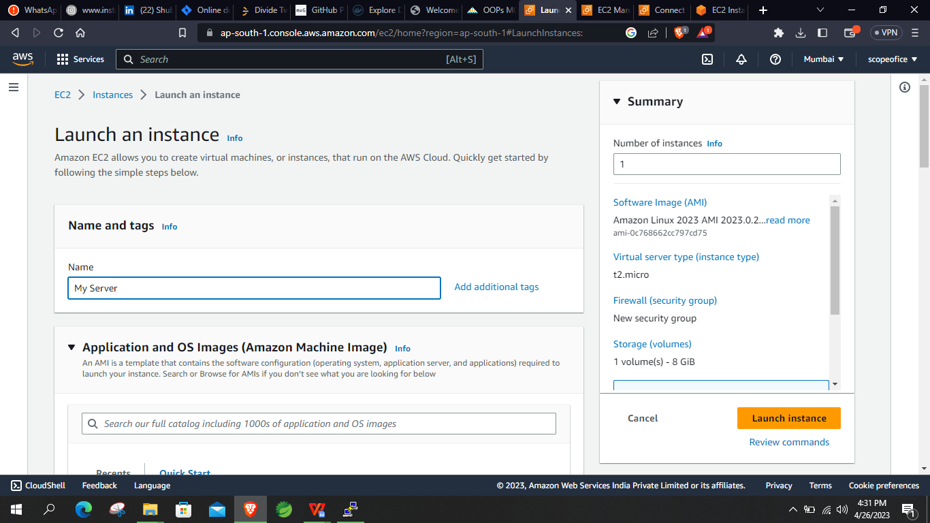

9.1 Select “Ubuntu”

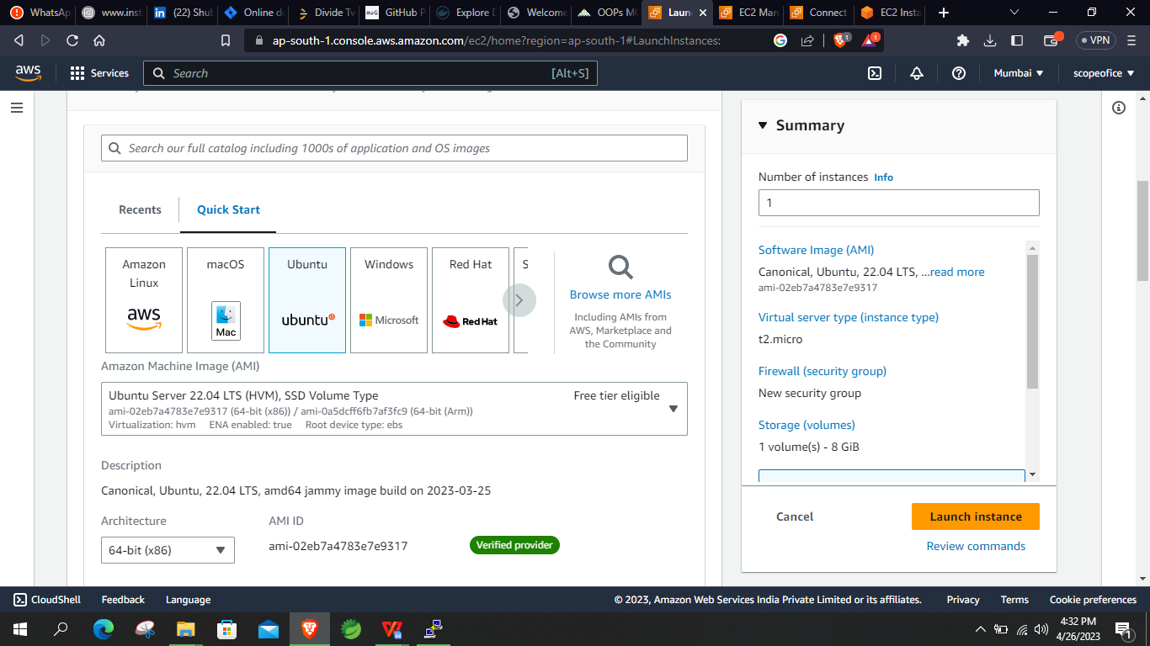

9.2 Select “Create new key pair”

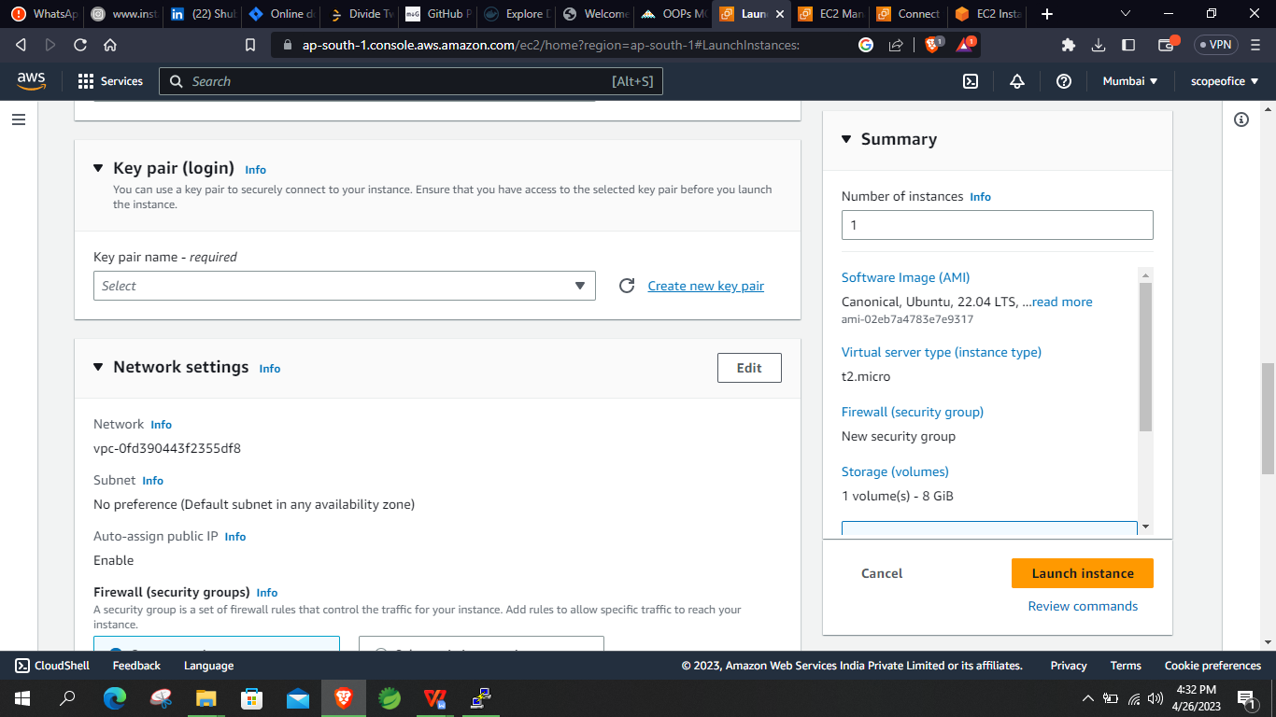

9.3 Give a name and Select “Create key pair”

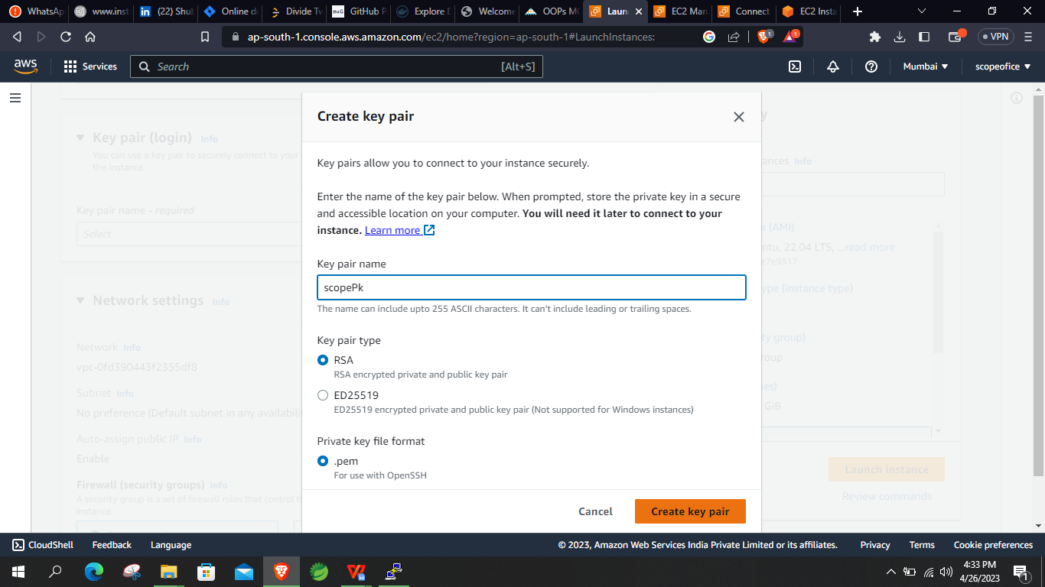

9.3 Click “Launch instance”

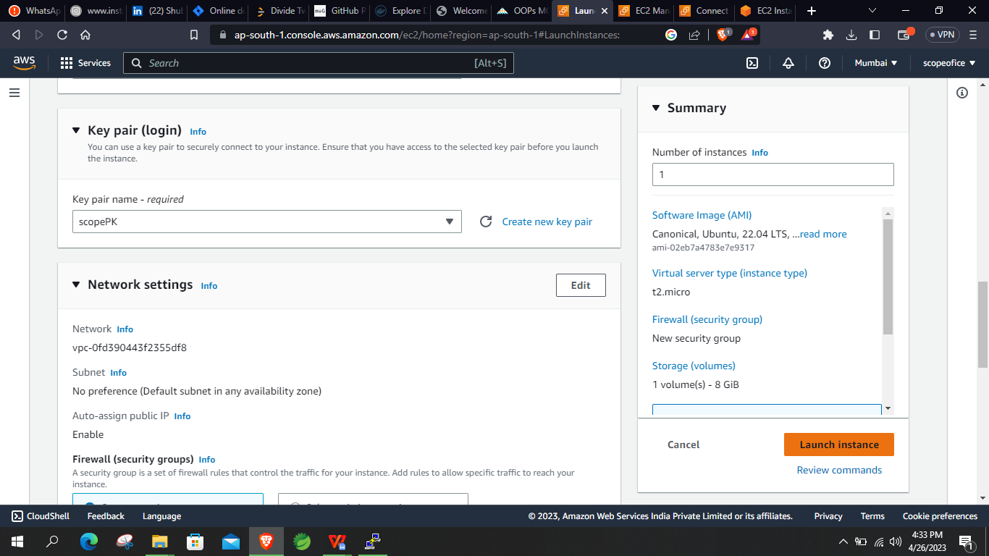

1. Click this checkbox.

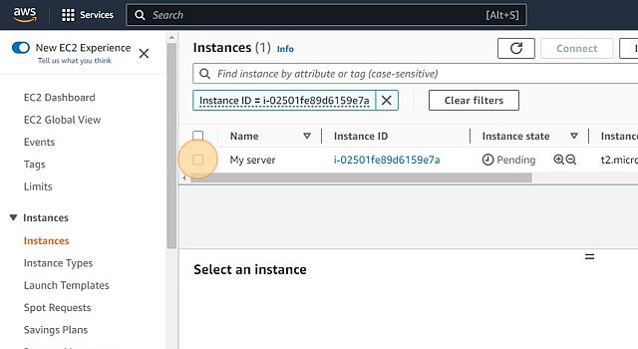

1. Click "Connect"

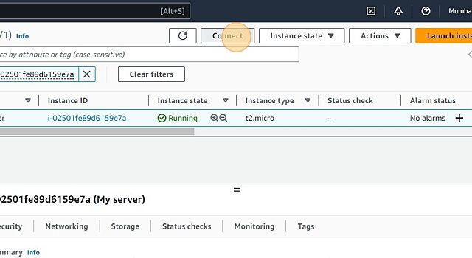

1. Click here.

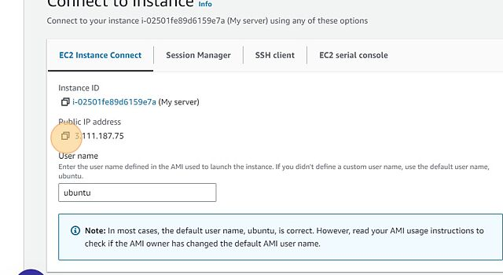

1. Click "Connect"

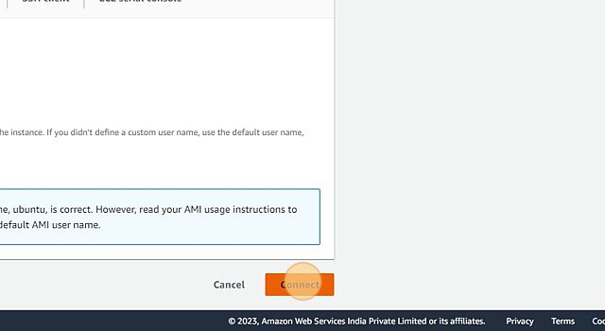

1. Click "Security Groups"

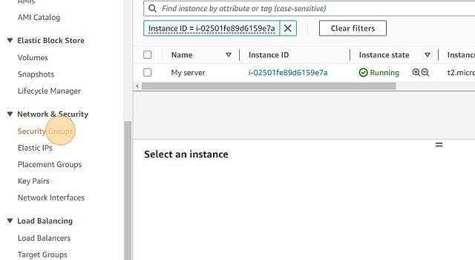

1. Select the last launch-wizard

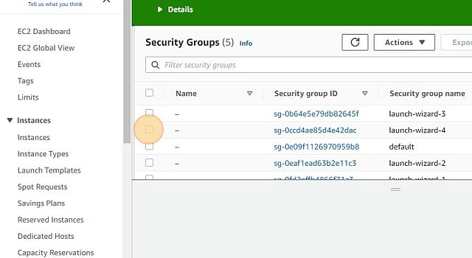

1. Click “Action”

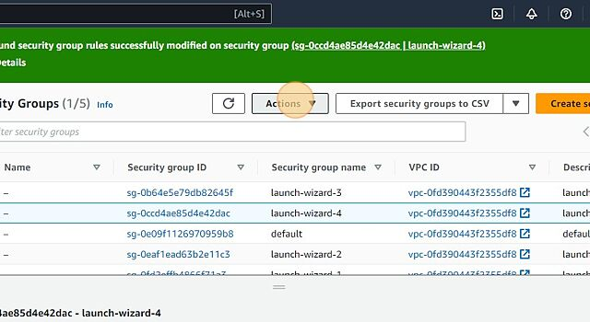

1. Click “Edit inbound rules”

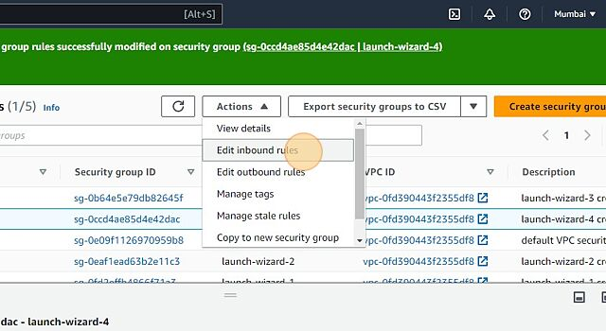

1. Click “Add rules”

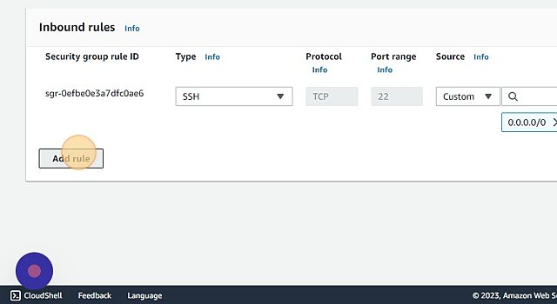

1. Click “Custom TCP”

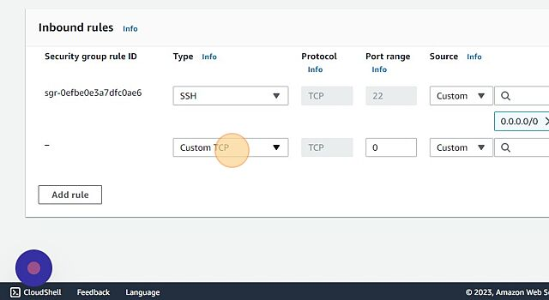

1. Click “Custom”

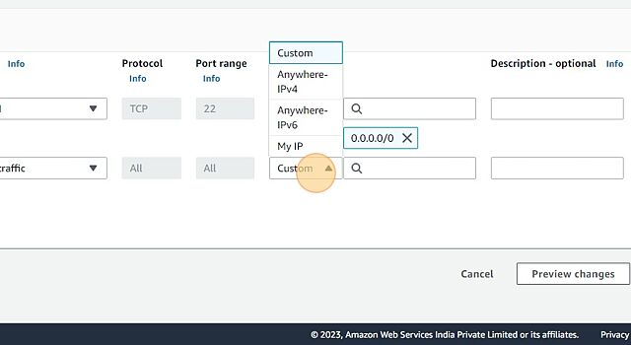

1. Click “Anywhere IP”

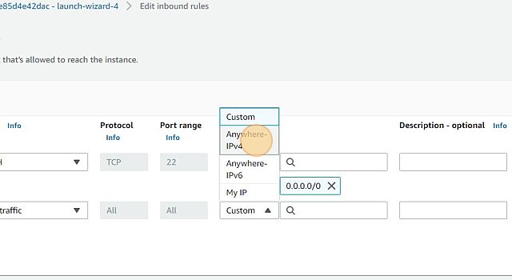

1. Click “Save rule”

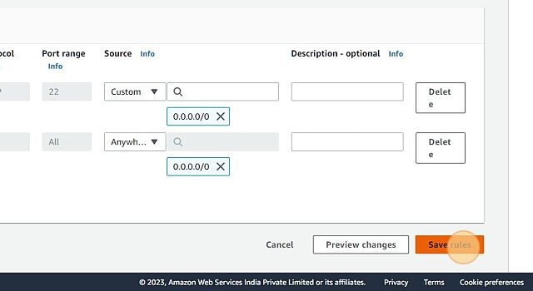

**PuTTY Commands**

1. Search PuTTYgen and open it

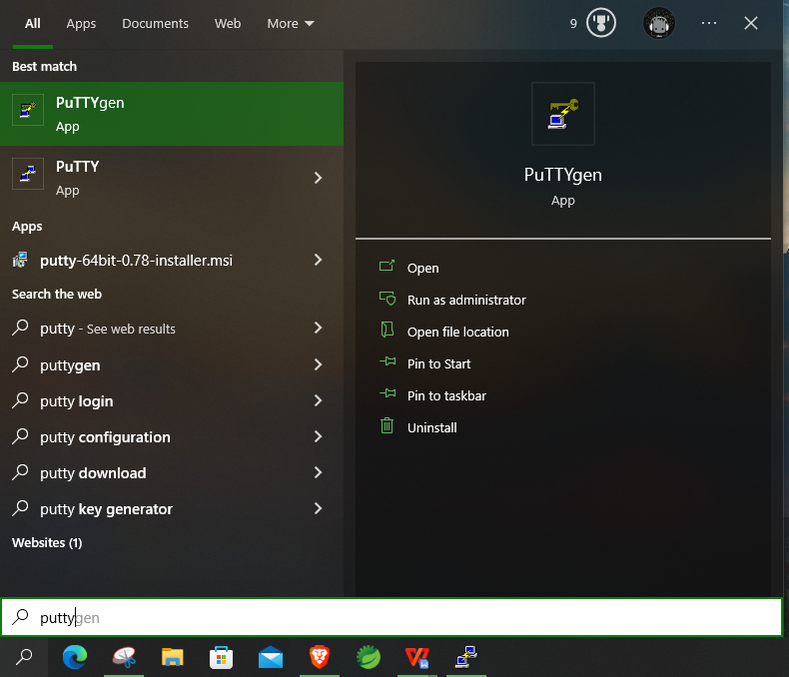

1. Click on “Load”

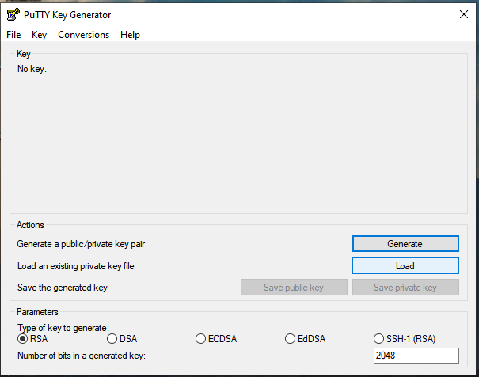

1. Select “All files*”

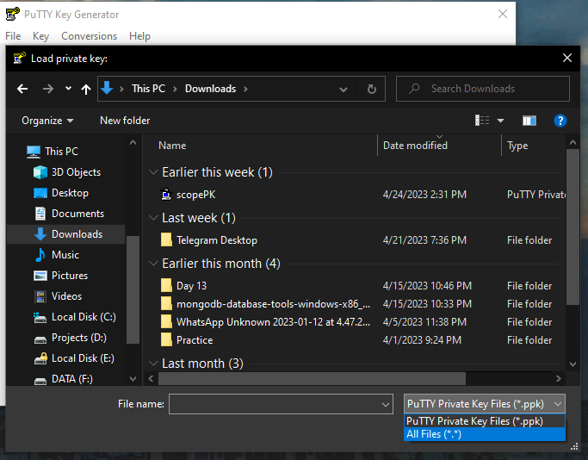

1. Open your key pair with “.pem” extension

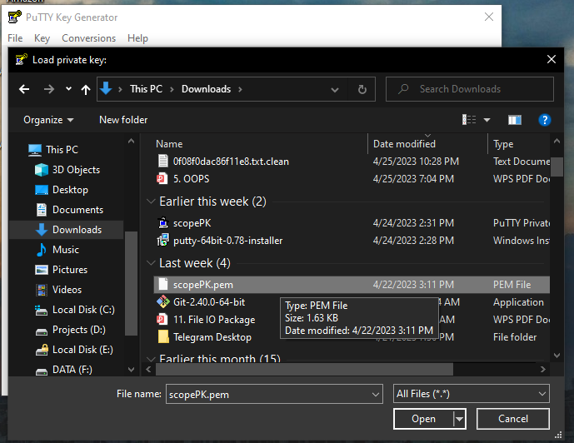

1. Click “ok”

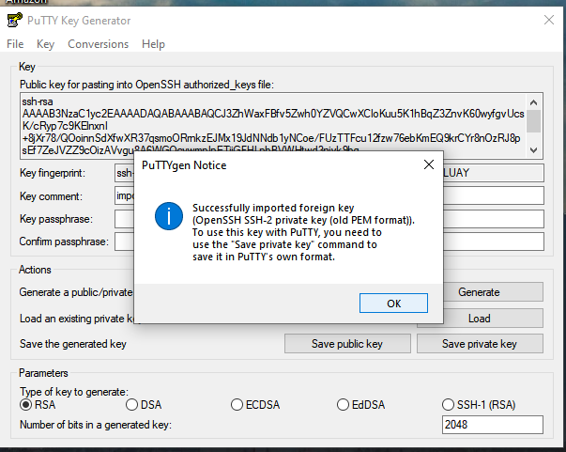

1. Select “Save private key”

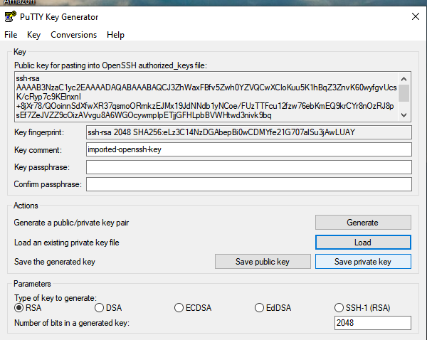

1. Click “Yes”

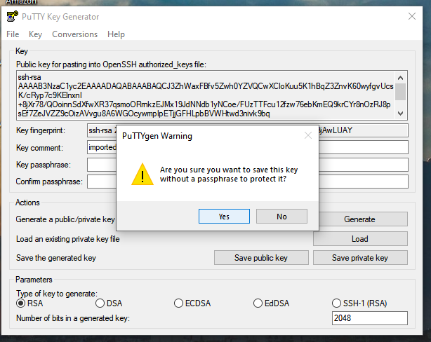

1. Save your private key

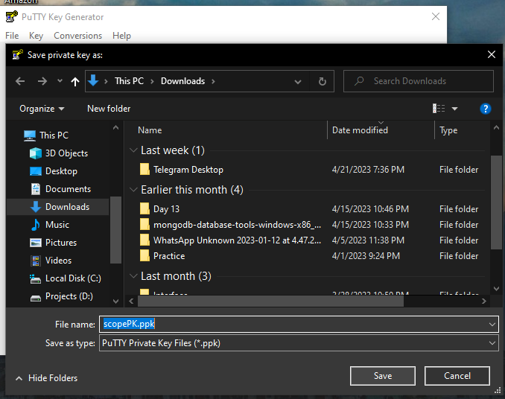

1. Now open PuTTY and paste IP address of your instance

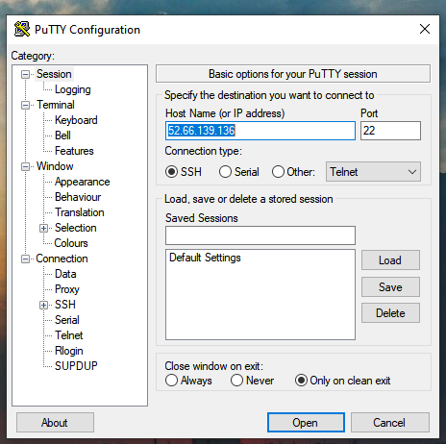

1. Select Data and type “ubuntu” in the Auto-login username

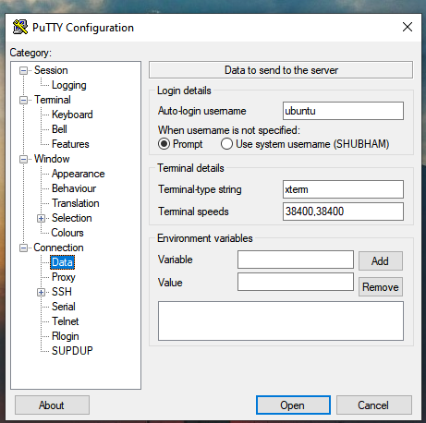

1. Go through “SSH>>Auth>>Credentials“ then browse your private key.

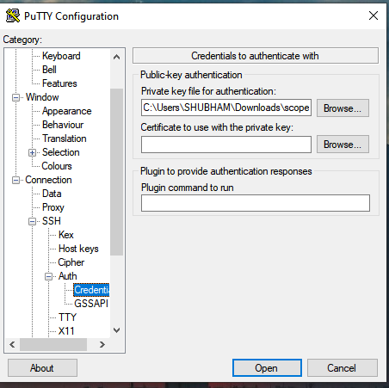

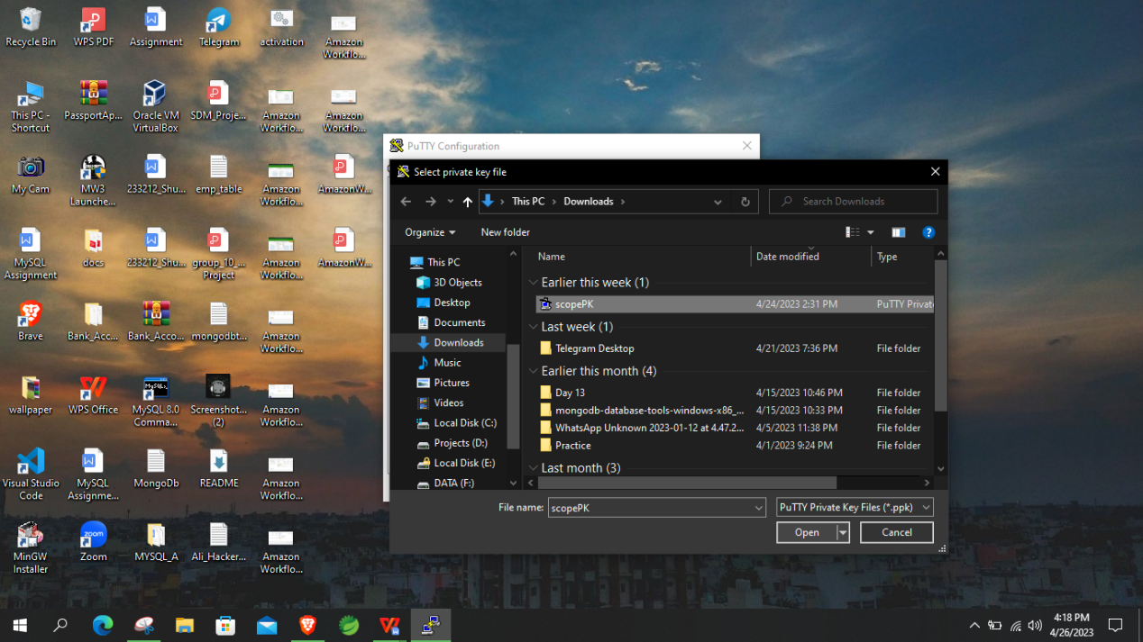

1. Click “Open”



1. Click “Accept”

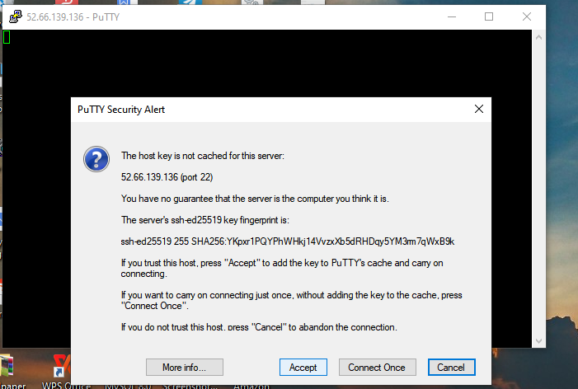

1. Type command- “sudo apt install”

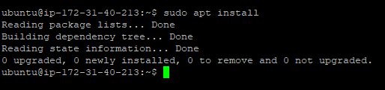

1. Type command- “sudo apt-get update”

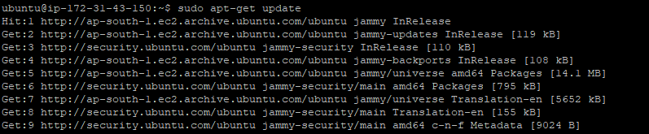

1. Type command- “sudo apt-get install docker.io” then “Y”

If installing for the first time- “ sudo apt install docker.io “

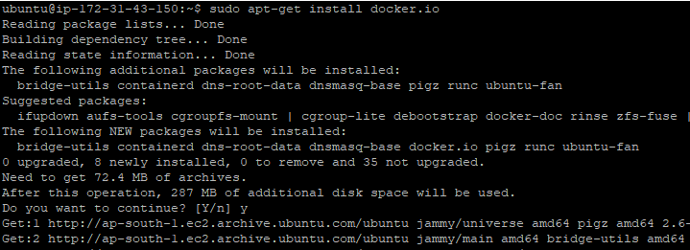

1. Type command- git clone <https://github.com/RaviTambade/iacsdrepomarch23.git>

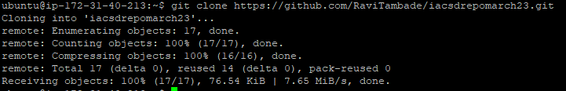

1. Type command- “ ls >> cd iascdrepomarch23>> ls >> sudo docker build -t iacsd . “ this is to build an image of the repo. Follow the steps carefully, you can type any name instead of iacsd and not there is a space and a dot after the name.

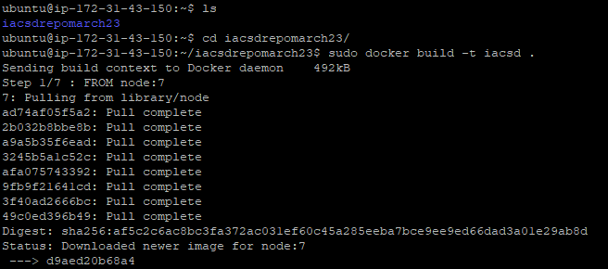

1. Type command- “sudo docker images ” to check if your image is created successfully.

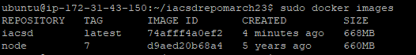

1. Type command- “ sudo docker run -d -p 8081:8081 iacsd “ you can give any 4 digit port number and at the end type the image name.

To check your image is running type command- “ sudo docker ps “

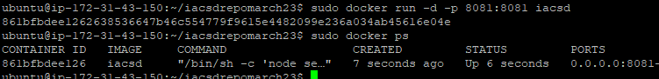

1. Copy your IP address and “ :8081 “ type the image port no. Press enter.

